Experiment -8

AIM

Design TM to perform

subtraction w=aaa-aa

Result =a

PROCEDURE

1. Start the automata
2. Enter the states
3. Connect the respective nodes (states) and self loop.
4. Enter the inputs values in the named nodes .
5. Compile the execution with suitable inputs
6. Stop the executions.

Design input:

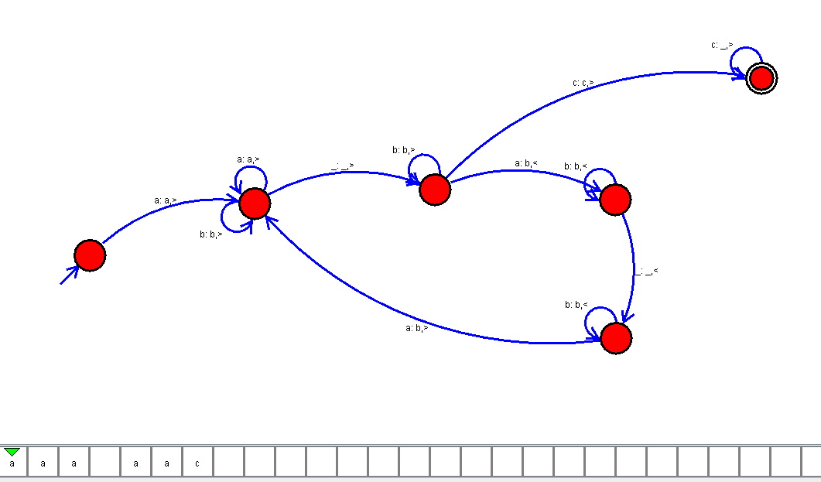

OUTPUT:

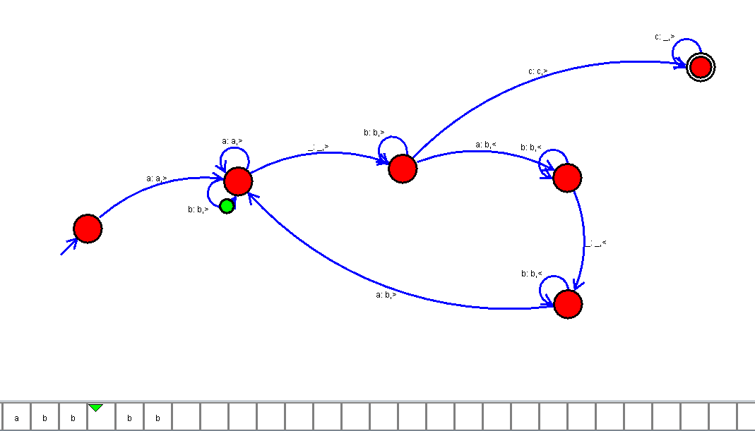

RESULT:

Thus the design of Tm to perform subtraction has been implemented and executed successfully.